Submission form – Development contributions rebate schemes

Your feedback will be considered before a decision is made.
We'll ask you some identifying questions, followed by questions about how you feel about each of the proposed schemes.

Anonymous submissions will not be accepted. Contact details are provided to elected members with your feedback to be considered when making their decision. We will also contact you with updates about the decision.
Submissions, including names, are published on this webpage, so please do not include any personal information you would prefer to keep private.
While contact details will not be published, if requested through the Local Government Official Information and Meetings Act 1987, these must be supplied. If there are good reasons why your personal details and/or feedback should be confidential, contact our Engagement Manager 941 8999 (0800 800 169).
View the Christchurch City Council Privacy Statement
- Are you responding: ^{Required}
Select one answer only

As an individual
On behalf of a recognised organisation
On behalf of a business
- First Name ^{Required}
- Last Name ^{Required}
- Name of organisation/business (if applicable)
Please ensure you have the authority to comment on behalf of this organisation/business.
- Your role (if applicable)
- Email ^{Required}
- Street name and number ^{Required}
If there are reasons your details and/or submission should be kept confidential, contact our Engagement Manager on 03 941 8999 (0800 800 169)
- Suburb ^{Required}
- Postcode ^{Required}
- Have you ever paid Development Contributions, or do you anticipate paying them in the next two years? ^{Required}
Select one answer only
Yes
No

Feedback

Existing demand credits in the central city rebate scheme.
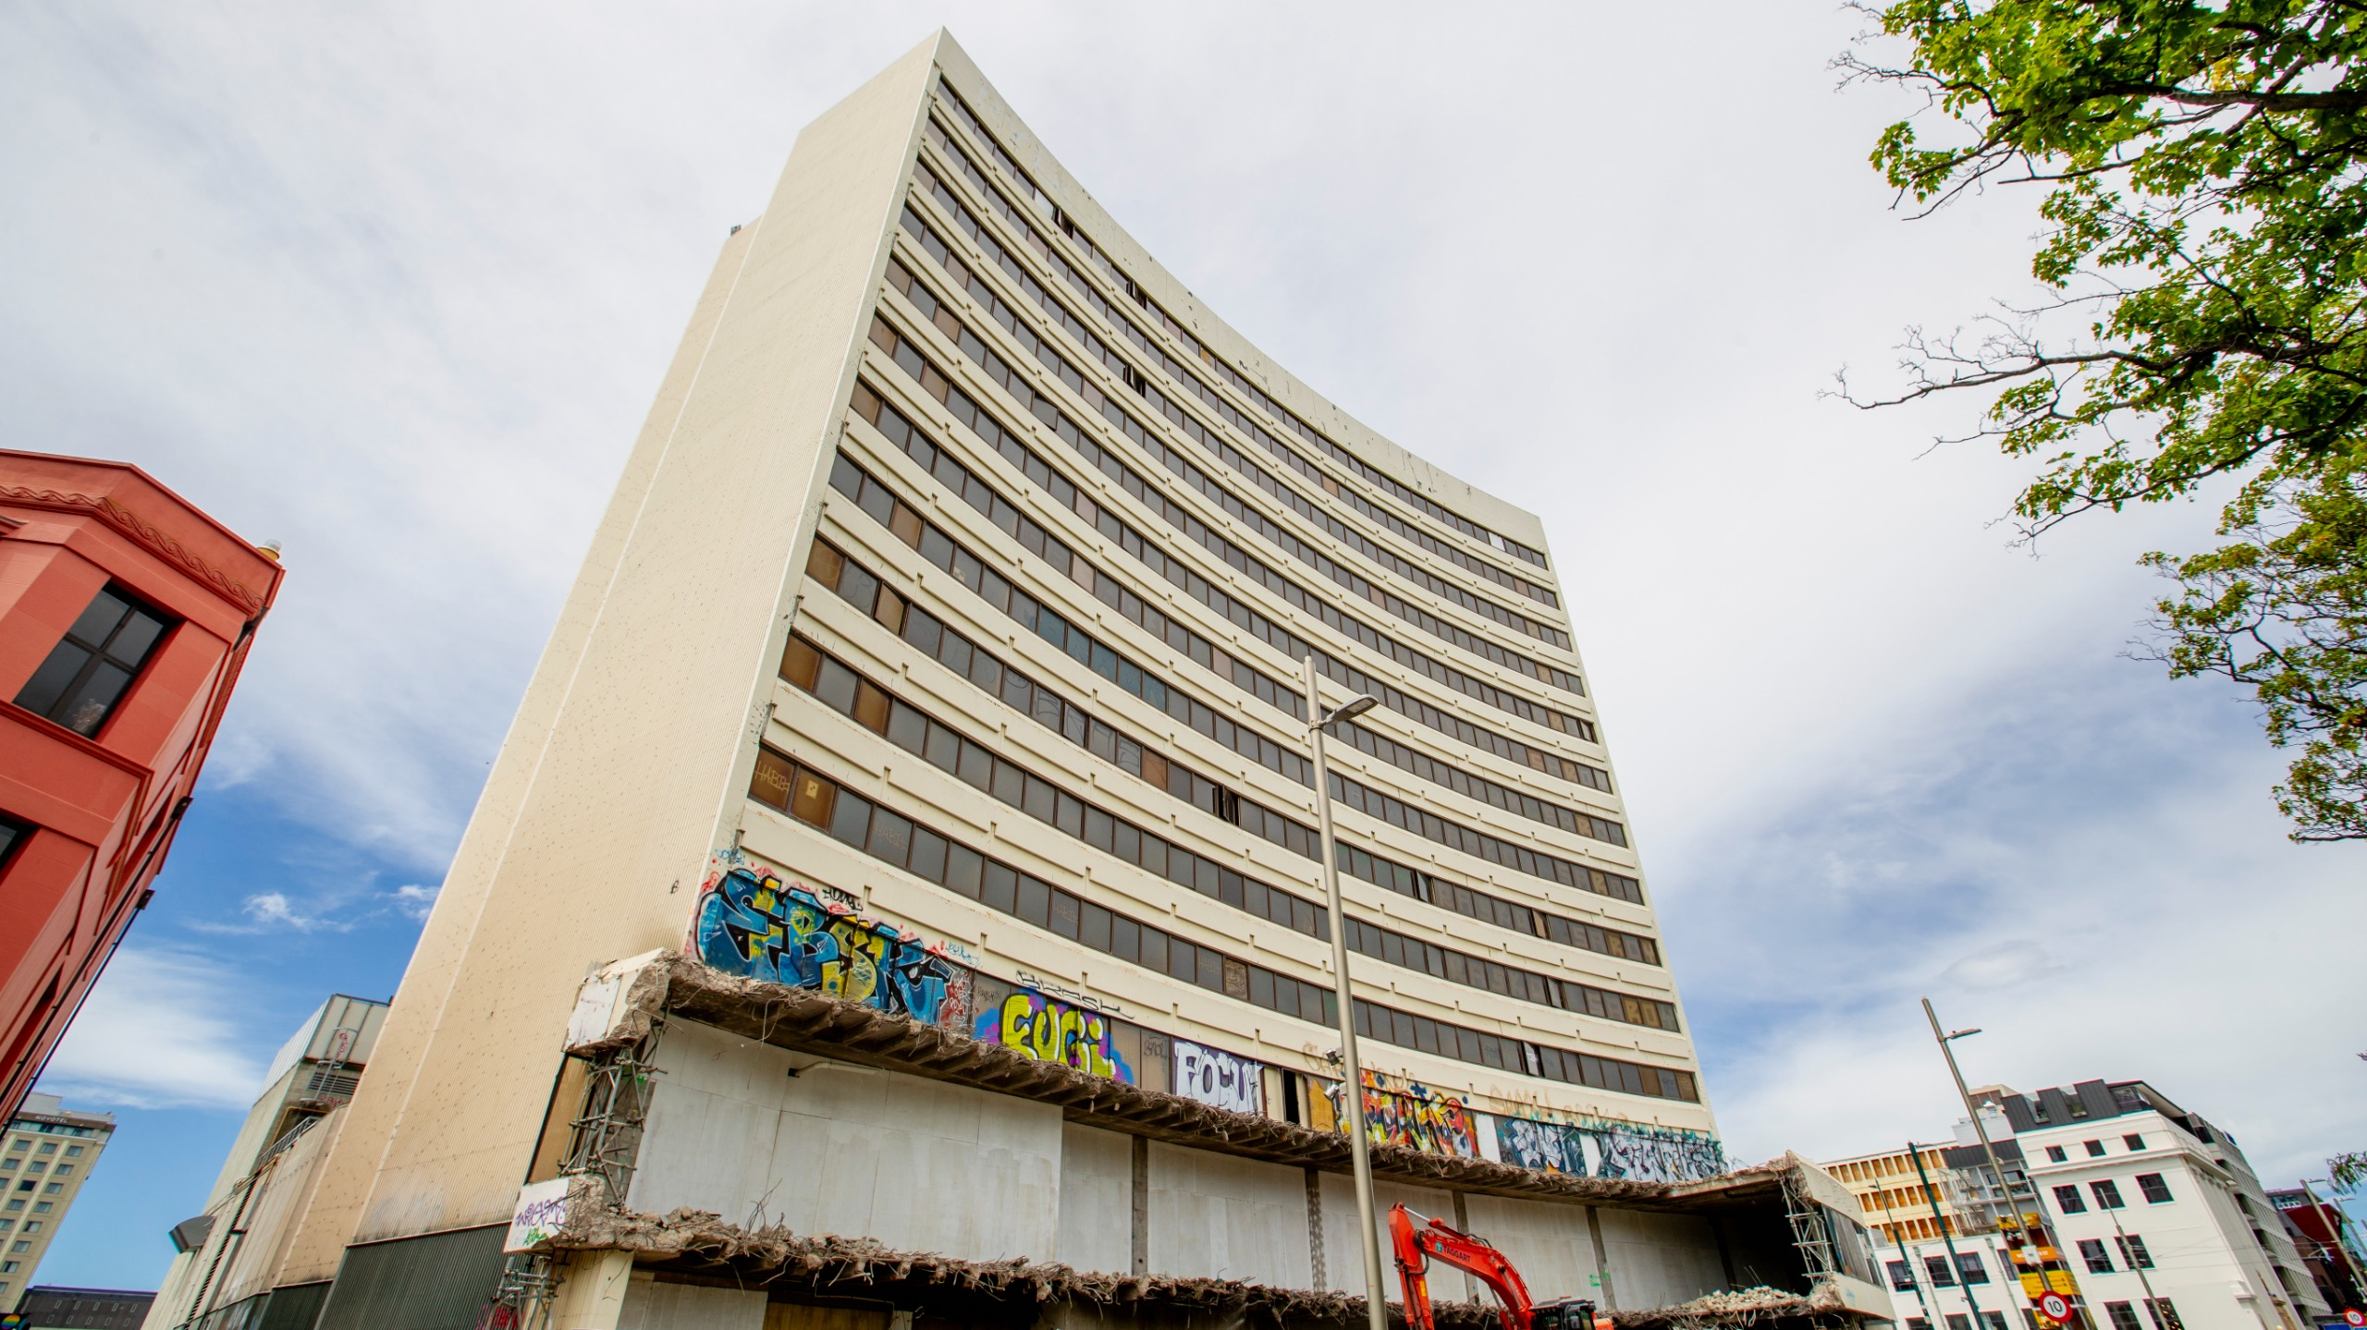
What do you like about the proposed existing demand credits in the central city rebate scheme, and why?
What don't you like about the proposed existing demand credits in the central city rebate scheme, and why?
Overall, do you support the proposed existing demand credits in the central city rebate scheme? ^{Required}
Select one answer only
Yes
Somewhat
No
Don't know / Not sure
Scheme 1 is currently limited to buildings standing on or after 1 March 2024. Would you prefer:
Select one answer only
The scheme is limited to buildings standing on or after 1 March 2024
The scheme be extended to include vacant sites (so that all central city sites would be included)
If any, what funding limit would you support for the scheme?
Select one answer only
None
2 million
5 million (proposed)
10 million
20 million
30 million

Six-story residential development in the central city rebate scheme.
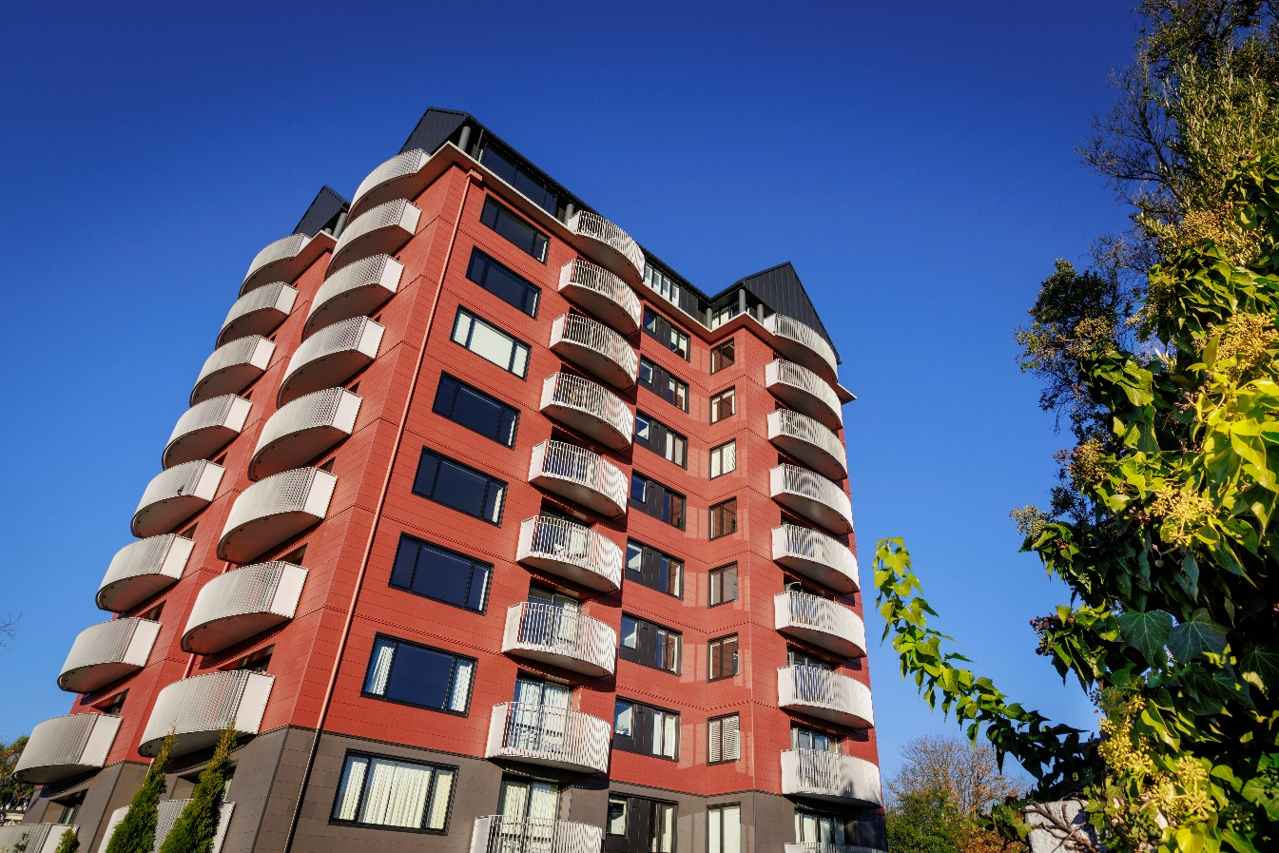
What do you like about the proposed six-story residential development in the central city rebate scheme, and why?
What don't you like about the proposed six-story residential development in the central city rebate scheme, and why?
Overall, do you support the proposed six-story residential development in the central city rebate scheme? ^{Required}
Select one answer only
Yes
Somewhat
No
Don't know / Not sure
If any, what funding limit would you support for the scheme?
Select one answer only
None
1 million
2 million (proposed)
3 million
5 million
10 million

Would you like the opportunity to speak to the Council or a panel about your submission?
Select one answer only
Yes
No
If so, please provide a phone number so we can arrange a speaking time?

